|  |
| --- |
| **SMART HOME AUTOMATION** |

**AIM :** To Change a Normal House into an Smart House

**Software Required : ARDUINO IDE**

**Components Required :**

* **Arduino**
* **Flame Sensor**
* **IR Sensor**
* **Sound Sensor**
* **Connecting Wires**

**Introduction : Smart homes provide convenience, safety, and energy efficiency. This project focuses on automating key safety and monitoring features using sensors:**

**Arduino : Arduino is a type of Arduino**

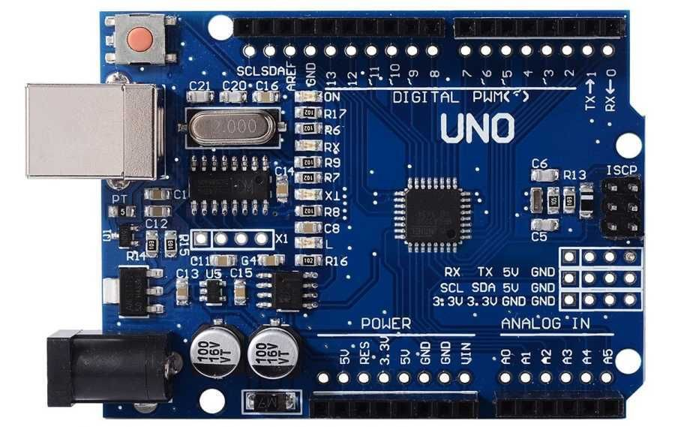**Micro controller it is the connection**

**between hardware & software**

**Using software we write**

**program or procedure and using**

**hardware we perform operations.**

|  |
| --- |
| **Key Specifications of Arduino UNO board:**   * **Microcontroller:** ATmega328P * **Digital I/O Pins:** 14 (6 with PWM capability * **Analog Input Pins:** 6 * **Operating Voltage:** 5V * **Power Options:** USB connection or external power source (7-12V)   **Flame Sensor : It is used to sense**  **the Fire in the locality**   * **Black absorbs the heat then black led is used** |

|  |
| --- |
|  |

|  |
| --- |
|  |

**IR Sensor : It is used to sense the**

**objects or obstacles in the locality**

* **5VDC Operating voltage**
* **I/O pins are 5V and 3.3V compliant**
* **Range: Up to 20cm**
* **Adjustable Sensing range**
* **Built-in Ambient Light Sensor**
* **20mA supply current**

|  |
| --- |
|  |

**Sound Sensor : It is used to sense**

**the Sound in the locality**

* **The operating current is 4~5 mA**
* **The voltage gain 26 dB ((V=6V, f=1kHz)**
* **The sensitivity of the microphone (1kHz) is 52 to 48 dB**
* **The impedance of the microphone is 2.2k Ohm**
* **The frequency of m microphone is16 to 20 kHz**
* **The signal to noise ratio is 54 dB**

**Advantages Of This Project:**

**With Arduino :**

* **We can store the Program or Procedure**
* **We can control the total Circuit**
* **At a time it perform only one task**

**With Flame Sensor :**

* **By using flame sensor in home we detect fire accidents**

**With IR Sensor :**

* **We can Detect the object**

**With Sound Sensor :**

* **In this with this Sensor I controlled the Lights & fans**
* **We can find rude activities**

**Team Members Info :**

1. **D.V.ANILKUMAR**
2. **B.MANOJ KUMAR**
3. **B.SIVA SUNDAR**
4. **G.MURALI KRISHNA**
5. **B.PEDDA VENKATESH**

**WORKING :**

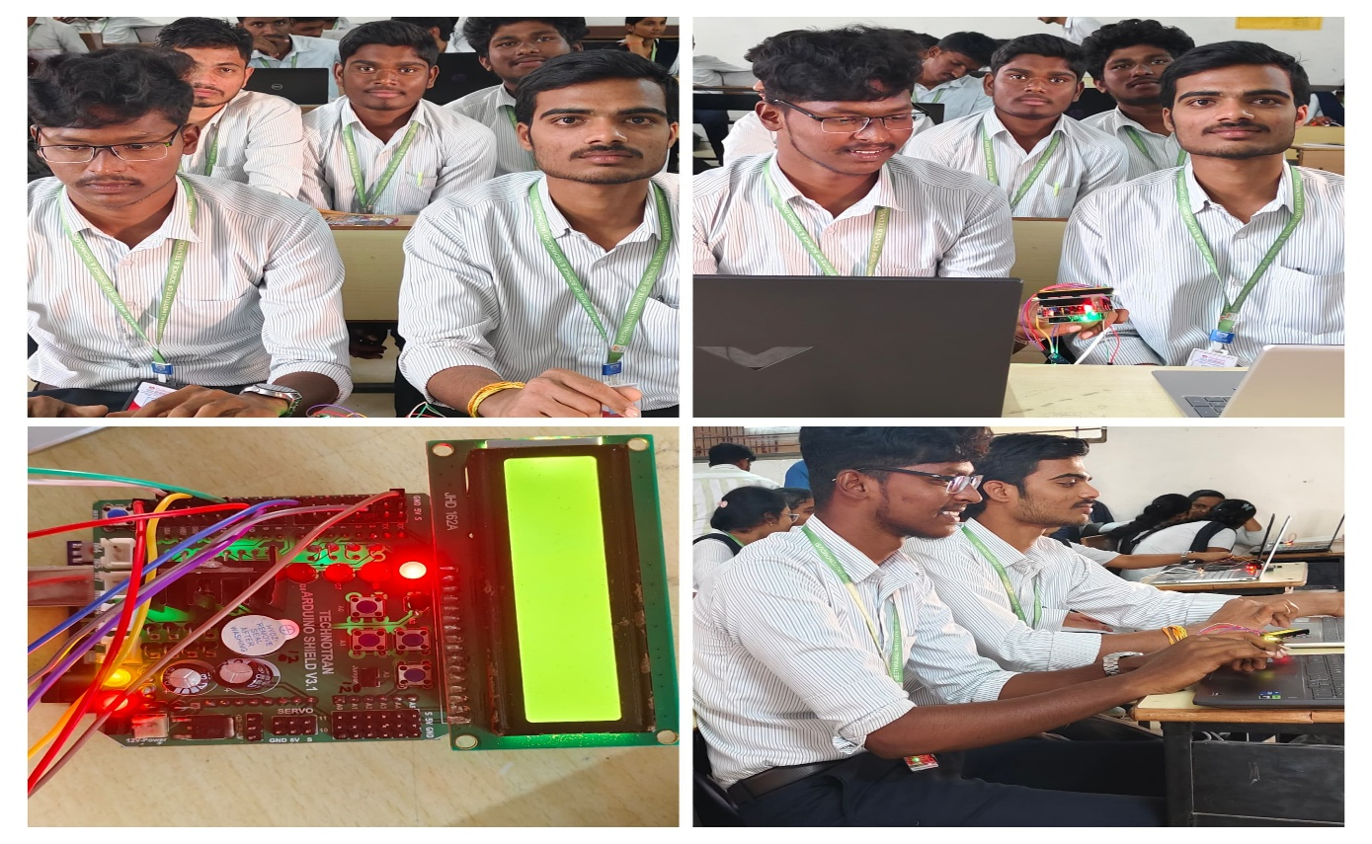

**Conclusion :**

**This is small smart house blueprint wen it installed**

**Physically it becomes very useful for us**